PVA Analysis Appendix
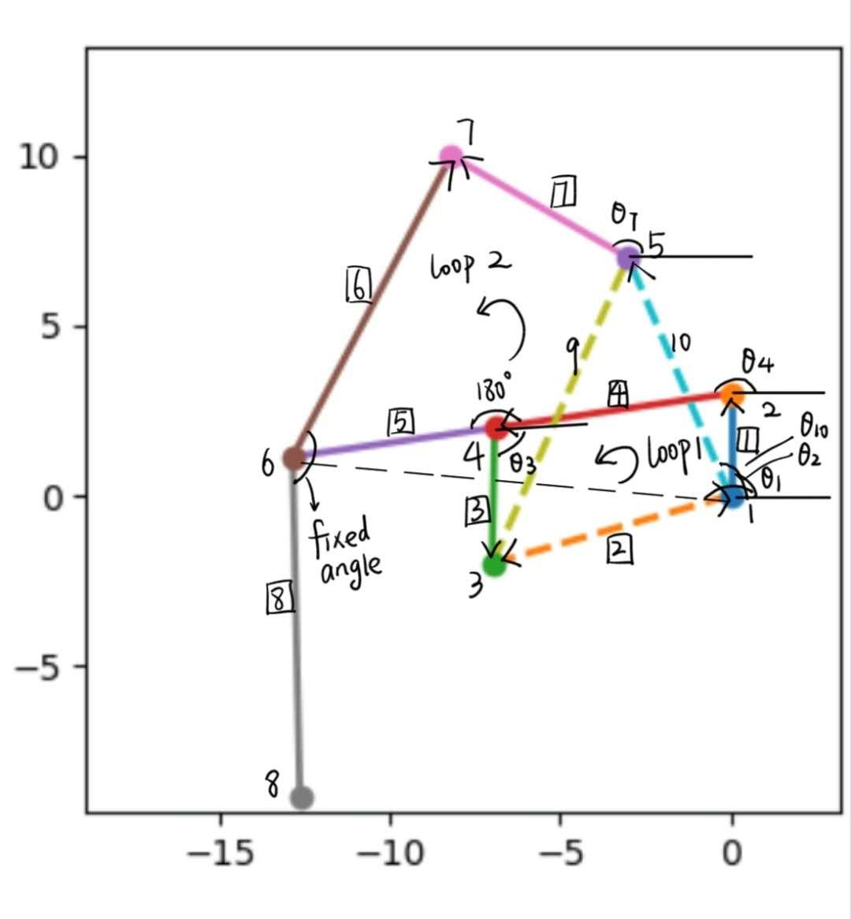
Step 1: PVA analysis:
Figure 1: Example of labelled leg mechanism defining links, relevant angles, vector loops, and positive orientations for position vector and angular position.
Known: All link lengths, angle$θ_{2}$, angle$θ_{9}$, angle$θ_{10},$are fixed. angle$θ_{1}$ is known. Link4 and link5 are rigid parts, link6 and link8 are rigid parts, the angle between the two linkages don’t change.
Loop1 (starting from ground O₂, and going clockwise)
$0= R_{3}⃑-R_{4}⃑-R_{1}⃑-R_{2}⃑= L_{3}e^{iθ_{3}}-L_{4}e^{iθ_{4}}-L_{1}e^{iθ_{1}}-L_{2}e^{iθ_{2}}$
Known: θ₁, θ₂; Unknown: θ₃, θ₄.
Loop2 (concluding node1, node6, node7, node5)
$0= R_{6}⃑-R_{7}⃑-R_{10}⃑-R_{1-6}⃑= L_{6}e^{iθ_{6}}-L_{7}e^{iθ_{7}}-L_{10}e^{iθ_{10}}-L_{1-6}e^{iθ_{1-6}}$
Known: θ₁₀, θ₁₋₆; Unknown: θ₆, θ₇.
For the position:
Loop1: Real: $L_{3}coscos \left(θ_{3}\right) -L_{4}coscos \left(θ_{4}\right) -L_{1}coscos \left(θ_{1}\right) -L_{2}coscos \left(θ_{2}\right)=0$
Imaginary: $L_{3}sinsin \left(θ_{3}\right) -L_{4}sinsin \left(θ_{4}\right) -L_{1}sinsin \left(θ_{1}\right) -L_{2}sinsin \left(θ_{2}\right)=0$
Loop2: Real: $L_{6}coscos \left(θ_{6}\right) -L_{7}coscos \left(θ_{7}\right) -L_{10}coscos \left(θ_{10}\right) -L_{1-6}coscos \left(θ_{1-6}\right)=0$
Imaginary: $L_{6}sinsin \left(θ_{6}\right) -L_{7}sinsin \left(θ_{7}\right) -L_{10}sinsin \left(θ_{10}\right) -L_{1-6}sinsin \left(θ_{1-6}\right)=0$
4 equations, to solve the 4 unknowns.
For the velocity:
Known: The angular velocity of the link1 and link2, through the fixed angle, we can know the angle$θ_{1-6}$, angle$θ_{3-4}$ and angle$θ_{6-P}$
Unknown: The angular velocity of the link3 and link4
Loop1: Real: $-L_{3}ω_{3}sinsin \left(θ_{3}\right) +L_{4}ω_{4}sinsin \left(θ_{4}\right) +L_{1}ω_{1}sinsin \left(θ_{1}\right) +L_{2}ω_{2}sinsin \left(θ_{2}\right) =0$
Imaginary: $L_{3}ω_{3}coscos \left(θ_{3}\right) +L_{4}ω_{4}coscos \left(θ_{4}\right) +L_{1}ω_{1}coscos \left(θ_{1}\right) +L_{2}ω_{2}coscos \left(θ_{2}\right) =0$
Loop1: Real: $-L_{6}ω_{6}sinsin \left(θ_{6}\right) +L_{7}ω_{7}sinsin \left(θ_{7}\right) +L_{10}ω_{10}sinsin \left(θ_{10}\right) +L_{1-6}ω_{1-6}sinsin \left(θ_{1-6}\right) =0$
Imaginary: $L_{6}ω_{6}coscos \left(θ_{6}\right) +L_{7}ω_{7}coscos \left(θ_{7}\right) +L_{10}ω_{10}coscos \left(θ_{10}\right) +L_{1-6}ω_{1-6}coscos \left(θ_{1-6}\right) =0$
For the acceleration:
Known: The acceleration of the link1, link2, link1-6.
Unknown: The acceleration of the link3, link4, link6 and link7
Loop1: Real: $-L_{3}α_{3}sinsin \left(θ_{3}\right) -L_{3}{ω_{3}}^{2}coscos \left(θ_{3}\right) +L_{4}α_{4}sinsin \left(θ_{4}\right) +L_{4}{ω_{4}}^{2}coscos \left(θ_{4}\right) +L_{1}α_{1}sinsin \left(θ_{1}\right) +L_{1}{ω_{1}}^{2}coscos \left(θ_{1}\right) +L_{2}α_{2}sinsin \left(θ_{2}\right) +L_{2}{ω_{2}}^{2}coscos \left(θ_{2}\right) =0$
Imaginary: $L_{3}α_{3}coscos \left(θ_{3}\right) -L_{3}{ω_{3}}^{2}sinsin \left(θ_{3}\right) -L_{4}α_{4}coscos \left(θ_{4}\right) +L_{4}{ω_{4}}^{2}sinsin \left(θ_{4}\right) -L_{1}α_{1}coscos \left(θ_{1}\right) +L_{1}{ω_{1}}^{2}sinsin \left(θ_{1}\right) -L_{2}α_{2}coscos \left(θ_{2}\right) +L_{2}{ω_{2}}^{2}sin⁡(θ_{2})$
Loop2: Real: $-L_{6}α_{6}sinsin \left(θ_{6}\right) -L_{6}{ω_{6}}^{2}coscos \left(θ_{6}\right) +L_{7}α_{7}sinsin \left(θ_{7}\right) +L_{7}{ω_{7}}^{2}coscos \left(θ_{7}\right) +L_{10}α_{10}sinsin \left(θ_{10}\right) +L_{10}{ω_{10}}^{2}coscos \left(θ_{10}\right) +L_{1-6}α_{1-6}sinsin \left(θ_{1-6}\right) +L_{1-6}{ω_{1-6}}^{2}coscos \left(θ_{1-6}\right) =0$
Imaginary: $L_{6}α_{6}coscos \left(θ_{6}\right) -L_{6}{ω_{6}}^{2}sinsin \left(θ_{6}\right) -L_{7}α_{7}coscos \left(θ_{7}\right) +L_{7}{ω_{7}}^{2}sinsin \left(θ_{7}\right) -L_{10}α_{10}coscos \left(θ_{10}\right) +L_{10}{ω_{10}}^{2}sinsin \left(θ_{10}\right) -L_{1-6}α_{1-6}coscos \left(θ_{1-6}\right) +L_{1-6}{ω_{1-6}}^{2}sin⁡(θ_{1-6})$
For the foot point P
$R_{P}⃑=R_{1-6}⃑+R_{6-P}⃑$
$R_{P}⃑=L_{1-6}e^{iθ_{1-6}}+L_{6-P}e^{iθ_{6-P}}$
For the velocity and acceleration
$V_{P}⃑=V_{1-6}⃑+V_{6-P}⃑$
$V_{1-6}⃑=V_{1-2}⃑+V_{2-6}⃑$
$V_{1-6}⃑=iω_{1}L_{1}e^{iθ_{1}}+iω_{4}(L_{4}+L_{5})e^{iθ_{4}}$
$V_{P}⃑=iω_{1}L_{1}e^{iθ_{1}}+iω_{4}\left(L_{4}+L_{5}\right)e^{iθ_{4}}+iω_{8}L_{8}e^{iθ_{8}}$

$A_{P}⃑=A_{1-6}⃑+A_{6-P}⃑$
$A_{P}⃑=iα_{1-6}L_{1-6}e^{iθ_{1-6}}-{ω_{1-6}}^{2}L_{1-6}e^{iθ_{1-6}}+iα_{6-P}L_{6-P}e^{iθ_{6-P}}-{ω_{6-P}}^{2}L_{6-P}e^{iθ_{6-P}}$
Interpreting and using PVA
The image below shows a simulated movement of the robot's legs to determine the contact and lifting phases of the robot's legs.
Figure 2. Identification of lift/contact phases in mechanism plot

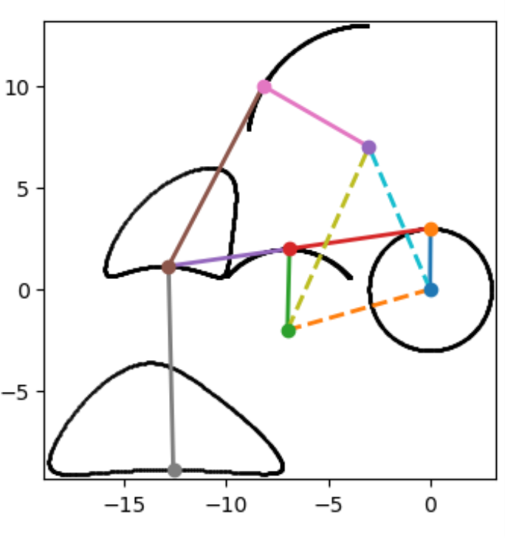

Lift Phase
Contact Phase
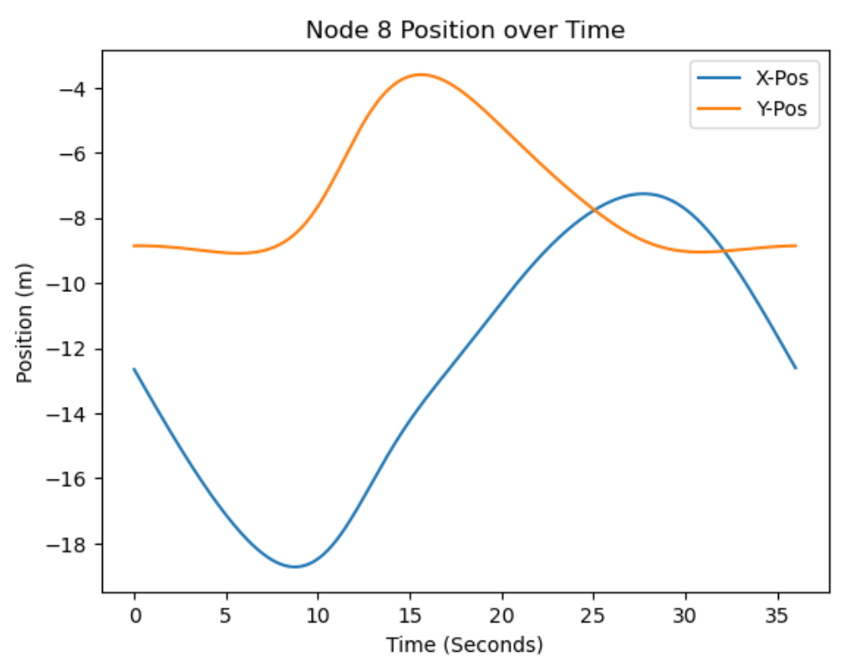

Lift Off Point
Contact Point
Lift Phase
Contact Phase
Figure 3. Identification of lift/contact phases from position diagram

As seen in the position versus time plot above, the contact and lift phases take an equal amount of time. This means that the foot is designed to be in contact with the ground for 50% of the crank, so β= 0.5. The gait sequence is shown below, with the leg numbers corresponding with the first figure in this document.
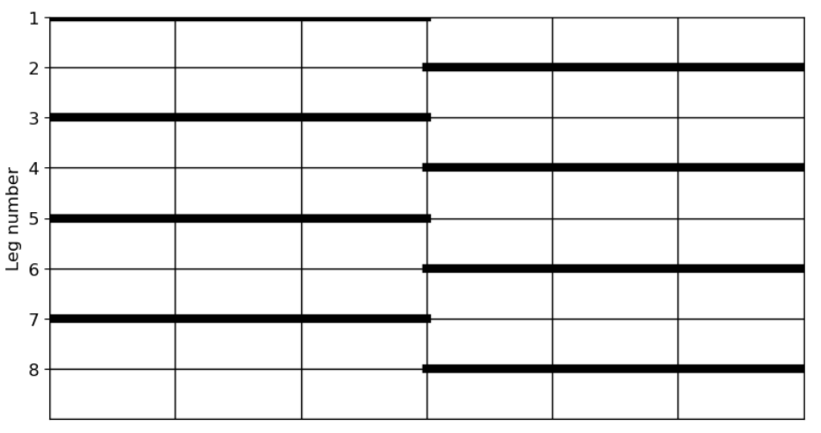
Figure 4. Gait sequence of The Klann Mechanism
The robot's stride length can be calculated by plotting the relationship between the robot's leg displacement and time.
$L_{s}=x_{lift}-x_{contact}=x\left(t=17.5s\right)-x\left(t=9.5s\right)≈10cm$
Calculate the crank angular velocity based on the duty cycle and step size.
$V_{Robot}=\frac{L_{s}}{βT}=\frac{(L_{s})(ω_{crank})}{β(2π)}$
$ω_{crank}=V_{Robot min}*\frac{β(2π)}{L_{s}}$
$ω_{crank min}=2\frac{m}{min}*0.5*\frac{2π}{0.1m}=62.83\frac{rad}{min}≈1.05s$

